
ANNUAL MEMBERSHIP
YOU MUST BRING A PASSPORT SIZE PHOTO.

PLEASE TICK: ✓ 16-18yrs ……… 19-24yrs ………
25-34yrs ……… 35-44yrs …......
44-54yrs ……… 55-64yrs ……...
64-74yrs ……… 75yrs over …….

Name in full: ……………………………………………………..……..……..…………

Address: ………………………………………………………………………..…..…….…

Post code: …………………………

Telephone no: ……………………….. Mobile no: ………………………………

E-mail address……………………………………………………

Can you please tick one of the following which best suits you.
The information is strictly for monitoring purposes.

1. Indian…… 2. Pakistani…… 3.Bangladeshi…… 4. Somali……5. Black………

6. White…… 7. Arab……8. African……... 9. Chinese…… 10. Other Ethnic Group……

Please specify ………………………………

What faith group do you belong to? (E.g. Sikh, Hindu, Muslim, Christian, Jewish, Non-Faith, Other)
Please specify …………………………………

Membership fee: £12.00 Adult membership
£ 4.00 Lost Membership Card

Please sign: ………………………………...... Date: ………………………….

Received by: ………………………………... Membership. No: ……………

We welcome your feedback to help improve our service.
Please contact Reception for a suggestions form.



New General Data Protection Regulation (GDPR) regulations

Dear Member/User

You may be aware of the new General Data Protection Regulation (GDPR) coming into force on 25th May 2018.This is about us keeping your confidential information safe and about you being aware of how we store and use your information. It is also to confirm that the information provided by you as a user involved in Shama Women’s Centre is used for promoting our activities, events and services and gaining feedback and information only. Your information will be held on our membership database mailing/email list according to your interests.
We are contacting you to seek your agreement for Shama Women’s Centre to continue to keep your details on our membership database and/or email list, and to contact you. We will insure that we
- Save your details in a secured database where only the relevant staff team members will have access to it.
- Will never share your details or pass onto another organisation or third party.
- Will only ever contact you to inform you of coming events and our services, obtain feedback.
If you wish to be removed from our database you may contact us via email, letter, and telephone or in person. Email address: shamaofficecentre@yahoo.co.uk or by calling 0116 251 4747
If you want to continue to be contacted by Shama please complete the form below and post to the following address.
Administrator
Shama Women’s Centre
39-45 Sparkenhoe Street
Leicester
LE2 0TD

Yours sincerely
Khudeja Amer-Sharif
Khudeja Amer-Sharif (CEO)
We look forward to your continued support.
Please complete and return
I confirm I am happy to receive communications by telephone, email and post as set above. Please tick: Yes [ ] No [ ]

Signed: Name:

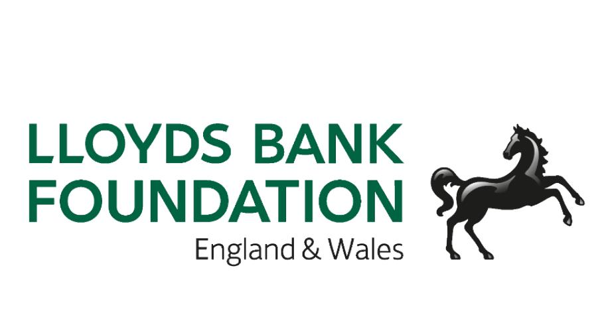
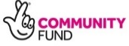
Date:

