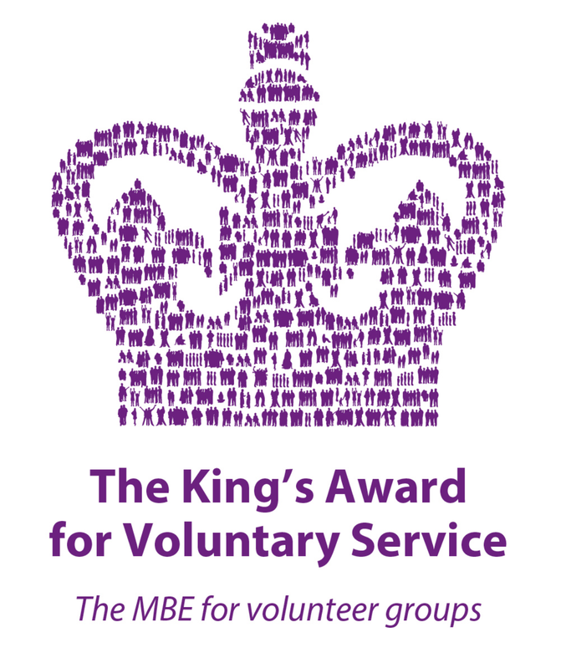
SHAMA WOMEN’S CENTRE

Safeguarding Vulnerable Adults Policy

- Introduction

Shama Women’s Centre has empowered thousands of vulnerable women since 1983, helping them to become socially, educationally and economically active and improve their health and wellbeing. We do this by providing a range of social, training and support programmes to help them to improve their confidence, access volunteering opportunities, gain employment skills; and keep them safe through our domestic abuse service and welfare rights support. We offer a mental health support service which includes counselling, and holistic therapies. We also provide an onsite gym and sauna to improve health and wellbeing and an onsite nursery to support women with young children to access our services.

- Policy Statement

As an organisation we take safeguarding seriously, to ensure the safety of our staff, volunteers and service users and work with other agencies to support our work. We review our policy regularly and annually to ensure that it is up to date with government guidelines/legislation.
The Management Committee/Trustees have overall responsibility for safeguarding and for ensuring that appropriate policies, procedures and practices are in place. Day-to-day safeguarding responsibilities may be delegated to the Safeguarding Lead, but the Trustees retain overall responsibility and oversight.
This policy is put into practice across Shama Women’s Centre and is responsive to changes in legislation, statutory guidance, organisational activities and safeguarding risks. It will be made available to the public, including through Shama Women’s Centre’s website or on request.

- Who does this apply to?

It is the duty of every organisation working with adults at risk to put appropriate safeguards in place. This policy applies to the Management Committee/Trustees, all employees (including sessional staff), volunteers, students/placements, contractors and partners working on behalf of Shama Women’s Centre. Beneficiaries and service users must also be made aware of how to raise a safeguarding concern. Everyone covered by this policy must understand and follow the safeguarding procedures relevant to their role.

- Equal Opportunities and Diversity
In recognition of Shama’s value statements, together with a commitment to equality and diversity, we aim to safeguard all those who may face inequality or harassment due to their ‘protected characteristics’ including age, disability, sex, sexual orientation, race, religion or belief, gender reassignment, marriage or civil partnership, pregnancy or maternity.
As detailed in our Equality and Diversity Policy, it is expected that staff and volunteers take proactive steps to respect and value differences for the benefit of all those they work with.

- Safeguarding our Staff and Volunteers
We are also committed to ensuring that our staff (including sessional staff) and volunteers are also protected as far as we are able. This begins at the recruitment stage and includes the various “safer recruitment” steps we take to identify where applicants are unsuitable in order to prevent potential safeguarding issues from arising in the future. Job descriptions, person specifications, our application form, the interview process and obtaining satisfactory references, alongside undertaking Disclosure and Barring Service (DBS) checks ensure the system we use to recruit is robust and effective at rooting out any unsuitable individuals.
Shama Women’s Centre will risk assess relevant trustee, staff and volunteer roles to determine whether a DBS check is legally available and, where it is, the appropriate level of check. Where a role involves contact with children or adults at risk but does not qualify for a standard or enhanced DBS check, the organisation will consider other proportionate safeguarding checks and risk-control measures.
We ensure both staff and volunteers receive adequate training at induction and that training opportunities are provided to ensure upskilling and keeping up to date with any legislative changes that may impact their delivery. The training looks at how the risks of abuse can be minimised, responsibilities of individuals for responding to allegations or concerns about suspected abuse.

Staff and Volunteers will receive regular supervision and their practice will be monitored by their Line Manager and the Management Committee to ensure adherence to safe working practices and organisational policies and procedures. We ensure that staff/volunteers are kept updated with the latest versions of our Safeguarding and other Shama policies; initially at induction, and then by email, acknowledging receipt of and understanding of the changes in the policies. We include safeguarding as a set item at staff team and management meetings; providing an opportunity to share best practice. Service users will be made aware of Safeguarding Policy/others at Induction, through the student handbook and receive revised policy documents by email.
Safeguarding training will also be provided or arranged for Management Committee members/Trustees as appropriate to their governance responsibilities. Training arrangements for trustees, staff and volunteers will be reviewed periodically to ensure that safeguarding knowledge remains current and relevant.
Safeguarding information and procedures will also be communicated, as appropriate, to Trustees, partners, contractors, beneficiaries and service users so that they understand how to recognise and raise concerns.
We have systems and procedures in place for staff/volunteers to adhere to protect and keep them safe from harm whilst undertaking their roles. Details can be found in various policies, including our Code of Conduct, Risk Management, and Lone Working Policy, which all staff/volunteers are issued with and receive training in.

- What is Safeguarding?

Safeguarding is about protecting individuals from abuse, harm and significant harm.
We all have the right to live our lives free from abuse. It is recognised that certain groups of people may be likely to experience abuse and less able to access services or support to keep themselves safe. One such group is people with community care needs. This group may include disability

- A learning .physical/sensory disability
- Victims of or risk of domestic abuse
- Mental ill health or dementia
- Frailty due to age
- Acquired brain injury
- A drug /alcohol problem
- Certain types of physical illness

- Adults at Risk

For the purposes of this policy, Shama Women’s Centre uses the term ‘adult at risk’. Under the Care Act 2014 safeguarding duties apply where an adult aged 18 or over: has needs for care and support (whether or not the local authority is meeting those needs); is experiencing, or is at risk of, abuse or neglect; and, as a result of those care and support needs, is unable to protect themselves from the risk or experience of abuse or neglect.

- Has care and support needs as specified under the Care Act 2014
- A person at risk of severe harm or does not appear to have the mental capacity under the Mental Capacity Act 2005 at the time to understand the situation.
- Is living in residential accommodation, such as a care home or a residential special school
- Is living in sheltered housing
- Is receiving domiciliary care in their own home
- Is receiving any form of healthcare
- Is detained in lawful custody (in a prison, remand centre, young offender institution, secure training centre, or attendance centre, or under the powers of the immigration and asylum Act 1999)
- Is under supervision of the welfare service, namely the provision of support, assistance or advice to live independently in accommodation or support their capacity to do so.
- Is receiving a service or participating in an activity for people who have particular needs because of their age or who have any form of disability
- Is an expectant or nursing mother living in residential care
- Is receiving direct payment from a local authority or health and social care trust in lieu of social care services, or requires assistance in the conduct of their affairs.

- What is abuse?

Abuse is defined as “the violation of an individual’s human or civil rights by any person or persons.”

Abuse can be:

- Physical - such as hitting, slapping, rough handling, misuse of medication, misuse of restraint. This includes cases of FGM, forced marriages, hate.

- Sexual – making someone carry out a sexual act they have not or cannot consent to.

- Psychological - such as threats or humiliation, radicalisation of an individual as described under the PREVENT strategy, cyber bullying.

- Financial or material – such as theft of money / possessions, misuse of someone’s benefits.

- Neglect – such as carer not meeting a person’s care health needs

- Acts of omission or self- neglect by the individual

- Discriminatory – Any form of abuse based on discrimination because of a person’s race, gender, age, disability, sexual orientation etc.

- Institutional – abuse or poor practice throughout an organisation.

- Domestic abuse can be perpetrated by anyone – relative, partners, friends, care workers, or strangers – and can happen anywhere.

- Modern slavery , exploited by gang masters/others

- County Line – Selling drugs

- Reporting Abuse:

Any staff member/volunteer/service user who witnesses abuse, or hears of it, or learns of a potentially abusive situation in relation to a vulnerable person must report it to his/her superior as soon as possible. A record of all concerns, disclosures and allegations should be kept in a confidential register which is kept securely and not accessible to all. Confidentiality can only be breached if an individual is at risk of severe harm or appears not have the mental capacity to understand the situation.

In cases where a staff member wants to make a disclosure about Shama as an organisation in relation to wrongdoing, abuse or unethical behaviour of an employee’, they are protected from suffering any detriment or termination of employment as outlined in Shama’s ‘ Whistle Blowing policy’. The concern should be reported by the staff member to Yasmin Nathani, MBE Chair of the Management Committee and the option to take it further to *Leicester City Council Adult Social Care Team if the member is not happy with it. All other concerns should be referred to the following in order of priority:

- Safeguarding Manager: Sultana Miah, Telephone: 07519 415370
- Safeguarding Deputy lead: Sajeeda Badat , Telephone: 0116 251 47 47
- Safeguarding Champion: Yasmin Nathani, MBE Chair of Management
Committee: Telephone: 07738 212639
- *In cases where an external referral is deemed necessary by a member of staff the Leicester City Council’s Adult Social Care ‘Contact and Response’ team can be contacted: 0116 4541004.

Serious incidents and Charity Commission reporting
Where a safeguarding incident is actual or alleged and results in, or risks, significant harm to beneficiaries, staff, volunteers or others who come into contact with Shama through its work, the Safeguarding Lead and Chair/Trustees will consider whether it meets the Charity Commission’s serious incident reporting criteria. Where required, the Trustees will ensure a prompt, full and frank report is made to the Charity Commission, as well as reporting to any relevant safeguarding authority, police or other regulator.
DBS referrals
Where the legal referral conditions are met, Shama Women’s Centre will make a referral to the Disclosure and Barring Service (DBS). Decisions and actions taken will be recorded appropriately.

In cases where there is concern about adults working with children; staff and
volunteers can contact Local Authority Designated Officer (LADO) Jude Atkinson
on 0116 454 2440. For further information please see Shama’s Child Safeguarding and Protection Policy.

- In cases where a service user wants to raise a concern about an employee they need to contact Yasmin Nathani, MBE Chair of Management Committee: 07738212639.

9a Informed consent *
In certain situations where an adult safeguarding referral is to be made or discussed, and in working with a vulnerable adult, a decision may need to be made as to whether he/she has the capacity for informed consent. In doing so, the principles of the Mental Capacity Act (2005) will need to be central to the decision as follows:
- A person must be assumed to have capacity unless it is established she/he lacks it
- A person is not to be treated as unable to make decision unless all practicable steps to help her/him do so have been taken
- A person is not to be treated as unable to make a decision merely because she/he` makes an unwise decision
- Anything done for or on behalf of the person must be in her/his best interests
- Before making the decision, other less restrictive options should be considered i.e.
- To consult with the named Safeguarding Deputy Lead (Sajeeda Badat) on 0116 251 4747
- if any doubt remains, and decisions should be made with the Safeguarding Lead (Sultana Miah) on 0116 251 4747 or 07519415370

- Data Protection & Confidentiality

All staff and volunteers involved with Shama’s work may have access to confidential and/or sensitive information about its beneficiaries and others who come into contact with the charity. Shama Women’s Centre has a commitment to keep its data and information confidential at all times and to abide by the UK General Data Protection Regulation (UK GDPR) and the Data Protection Act 2018.
Any information relating to Shama Women’s Centre, staff, volunteers, beneficiaries, agencies, stakeholders and partners must NEVER be discussed with any family, friends or other external contacts unless specifically authorised to do so ( see exception under *informed consent).
All staff and volunteers must only collect necessary personal information and data. It must always be shared and stored securely.

Please see attached Shama Women’s Centre’s Safeguarding Protocol for dealing with concerns, disclosures and allegations (Attached Appendix)

11 .Review of Policy

This policy will be reviewed at least annually to ensure that it remains up to date, legally compliant and reflects the needs, activities and safeguarding risks of Shama Women’s Centre. It will always be reviewed following a serious safeguarding incident or significant near miss.
Following safeguarding concerns, serious incidents or significant near misses, Shama Women’s Centre will review what happened, identify and record any lessons learned, and use those lessons to improve safeguarding procedures, training, risk management and organisational practice.

The policy will also be reviewed when relevant legislation, statutory guidance or Charity Commission guidance changes; when Shama changes the way it delivers services; or where monitoring, learning, complaints or safeguarding concerns indicate that policy or practice should be changed.

Date reviewed 30/09/2026

Date of next review 30/09/2027

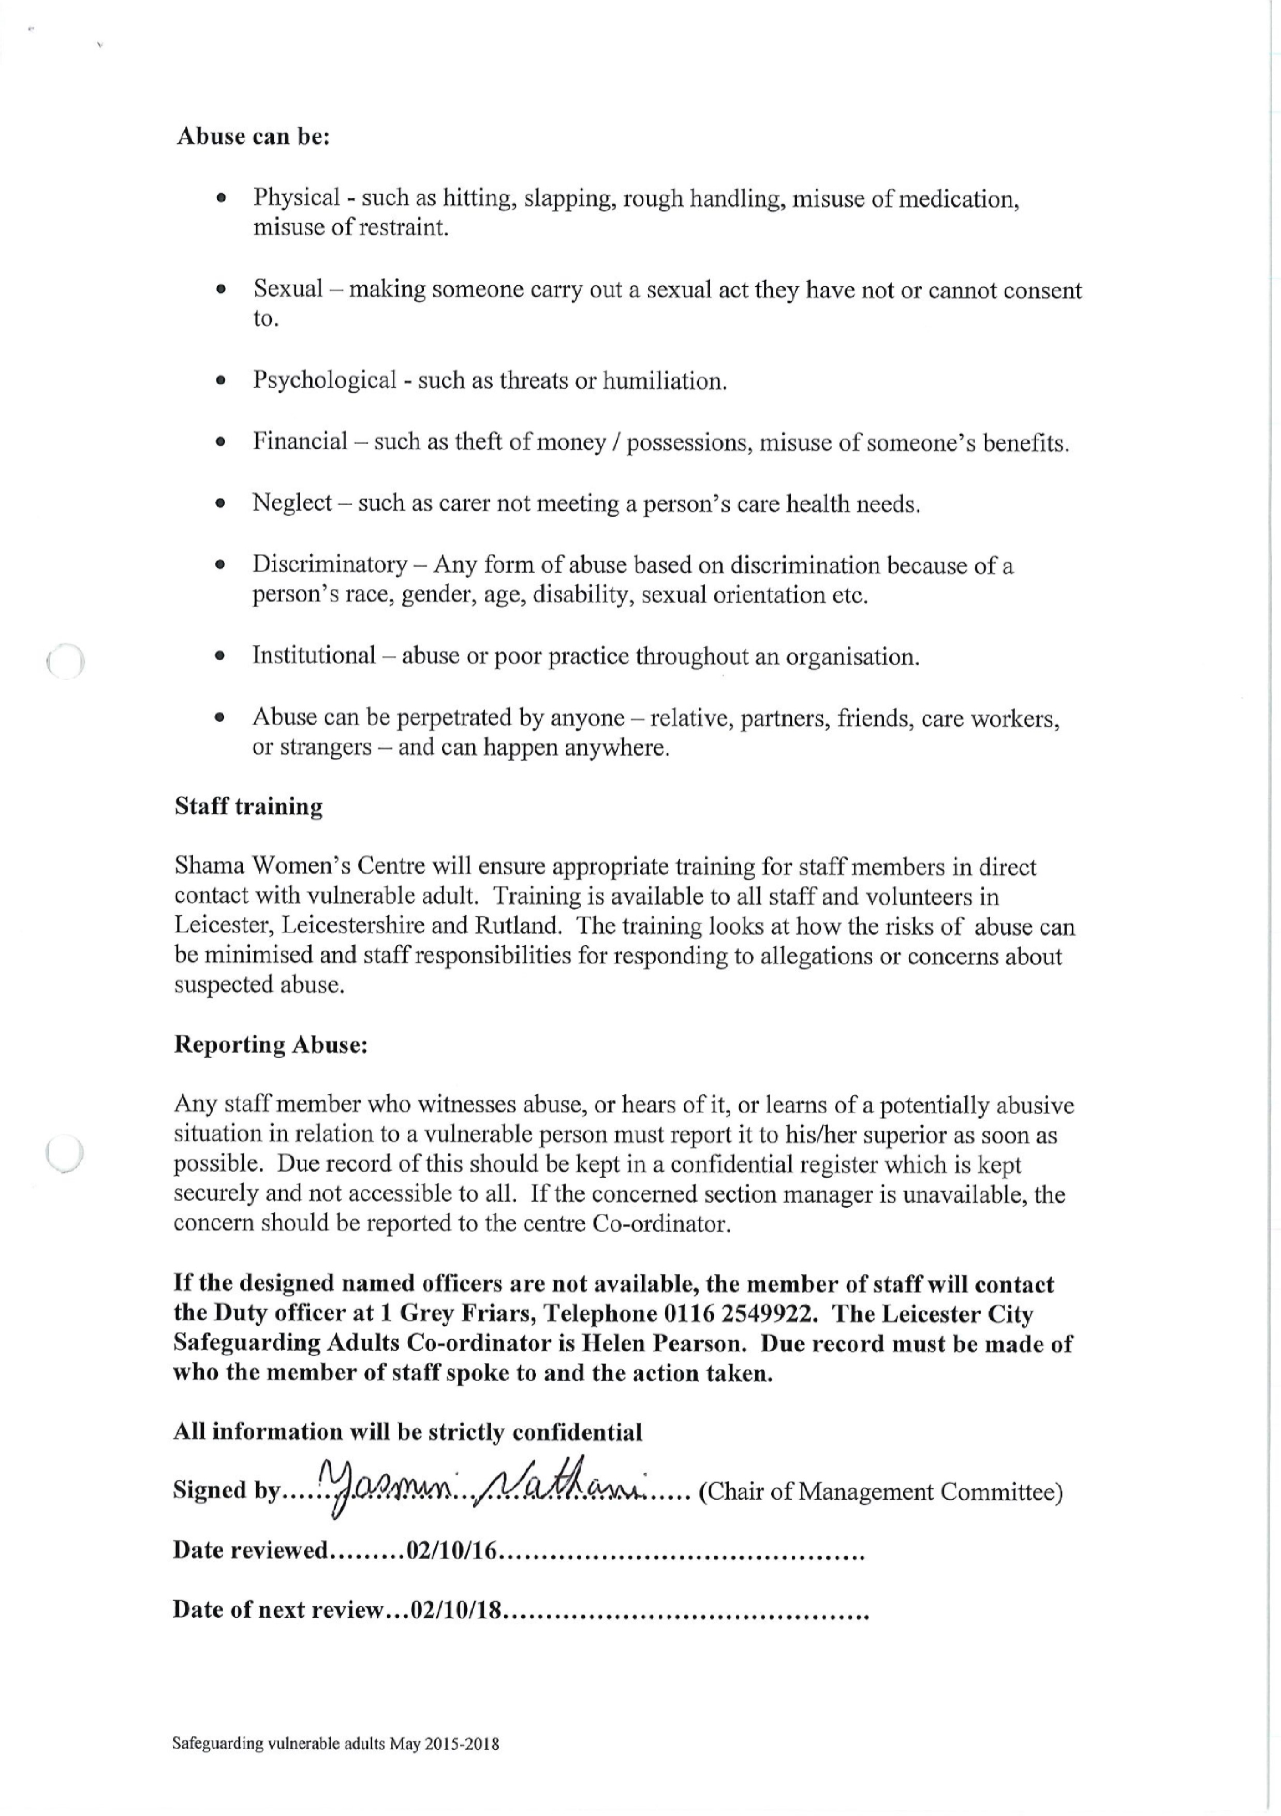

.

Appendix

Shama Women’s Centre’s Safeguarding Protocol

This protocol is an appendix to our Adult Safeguarding Policy and runs alongside the following Shama policies:

- Equality & Diversity Policy
- Child safeguarding and protection policy
- Staff recruitment and selection policy
- Whistleblowing Policy
- Data protection and GDPR Policy
The aim of this protocol is to ensure that staff, volunteers and service users are clear as what action to take and when, to safeguard vulnerable individuals, and what constitutes a cause for concern .This covers contact by telephone, social media, email and on-line platforms, and documentation with vulnerable service users.
This action to safeguard can constitute a breach of Shama’s commitment to confidentiality, putting the safety of the vulnerable individual first.

2. If you have a Cause for Concern
On occasion’s staff or volunteers may be become concerned about the manner of and what is being said by an individual, their body language in the way they express themselves, this could be a service user or someone who contacts the Centre. The individual may report abuse, fear, neglect, violence, suicidal thoughts to name a few. It’s important that you know how to deal with this situation; particularly as many of our services users are vulnerable. In this case staff/volunteers must clarify the situation with the individual, establish the facts so the information is accurately represented.
Certain roles such as mental health counsellors will also undertake more detailed professional assessments such as the PHQ9 and GAD 7 to determine the level of risk. Whereas the Domestic Abuse Worker would undertake a DASH risk assessment with clients to determine the level of risk. However the process outlined in this protocol applies to all staff and volunteers who may come across an individual that requires safeguarding.

3. Next steps if you have a Cause for Concern
If staff feel they have a reason to be concerned about an invidual, this could be a counselling client, general caller, service users accessing learning and training workshops or other services, staff need to decide:
- if the concern warrants steps to safeguard the individual and if the steps will require a breach of data confidentiality (see 9a informed consent)
- Identify who or which organisation to escalate the concern to.
- To consider how much prior warning needs to be given to the individual before escalating the concern .This involves weighing up the risk of not taking any action on the individual versus the risk on Shama’s reputation.
In order to support you and safeguard the individual we have the following safeguarding protocols in place.

Protocols for Safeguarding at Shama Women’s Centre
This applies to staff, volunteers who have cause for concern, for the safeguarding of an individual; including disclosures and allegations. This could be as a result of a phone call, face to face or virtual platform social media, and documentation; or a DASH risk assessment undertaken by DA Worker.

1. Staff member identifies a cause for concern for safeguarding

Keep the person calm, offer support

Explain that you may need to share this information. (Note: Informed consent

Inform them of next steps

Complete recording form for a concern (Appendix 1)

If imminent risk contact emergency services or ask a colleague to do so

2. Inform the Safeguarding Lead
Sultana Miah - 0116 251 4747 / 07519 415370 or Deputy Lead Sajeeda Badat – 0116 2514747 or the most senior staff on duty and discuss

How to manage the current situation

Whether to share and refer person to external agency and if so by whom and how (see list of agencies Appendix 3)

If so, complete a Shama Safeguarding Referral form
(Appendix 2) or external agency form, where appropriate

Refer to DA worker (Sultana) to complete dash risk assessment

3. Note any follow up actions and pass the form for storage

Give the form to Sultana Miah / Sajeeda Badat, who will store the form securely for service user records.

Sultana Miah (Safeguarding Lead) will note any safeguarding issues for reporting to Shama
Director’s and share any relevant information
with the CEO.

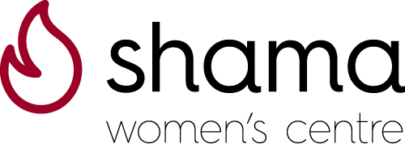Appendix 1

Shama Women Centre Recording form for a Concern of Harm/Abuse or Disclosure

1. Clients Name: ……………………………………………………………………….

2. Nature of Concern / Disclosures: ……………………………………………………
…………………………………………………………………………………………….

…………………………………………………………………………………………….

3. Name of Assessor Staff/Volunteer: …………………………………………………

4. Name of Client: ……………………………………………………………………..

Address………………………………………………………………………………

Email: ……………………………………………………………………………….

Telephone Number: ………………………………………………………………….

5. Information Shared with Safeguarding Lead Yes No

Date Shared: ………………………………………………………………………...

6. Safeguarding Lead
Name………………………………………………………………………………………

Email ……………………………………………………………………………………...

Telephone: ………………………………………………………………………………..

Actions/Outcomes:

7. Additional Action Required:

Refer to external agency Date completed: …………………

Complete Shama Referral Form

Complete External Form

Appendix 2
Strictly Private & Confidential

39-45 Sparkenhoe Street
Leicester, LE2 0TD
SHAMA WOMEN’S CENTRE
DV REFERRAL FORM

Tel/Fax: (0116) 251 4747
E-mail: Sultanadvswc@yahoo.com
E-mail: info@shamawomenscentre.co.uk
Website: www.shamawomenscentre.co.uk

Please note, all boxes will expand when typing

Section 1 - REFERRERS DETAILS
Name of Organisation:
Referred by
Name & Position:
Telephone:
Email:
Date of referral:
Reason for referral: | (DA consists of physical, mental, sexual, economic abuse. HBV FGM and FM, Mental health issues. Other : suicidal thoughts, self-harm, neglect , homelessness, substance misuse, please specify)
Section 2 - CLIENT DETAILS
Client Name:
Address:
Telephone:  Email: | Preferred contact method
Date of Birth:
Equalities Data
Ethnicity: | Nationality: |  |  | Preferred language:
Disability | Yes / No |  | If yes please specify:
Gender | Male / Female | Gender reassignment |  | Yes / No / Prefer not to say | Sexual Orientation
Is Victim Pregnant | Yes / No
Employment Status
Immigration status:
(e.g. asylum seeker, refugee, spousal visa with NRPF, ILR)
Doctor’s Surgery
(if applicable)
Client’s consent given? | Yes / No
Risk Profile
Please give details of any risk related information:

Section 3 - PERPETRATORS DETAILS
Full Name
Address:
Telephone:  Email: | Preferred contact method
Date of Birth: | Gender:
Ethnicity: | Religion:
Immigration status:
(e.g. asylum seeker, refugee, spousal visa with NRPF, ILR)
Section 4 - DASH & RISK ASSESSMENT
Has a DASH risk  Assessment been done? | Yes / No Date:
Has Information been Shared? | Yes / No Date:
Agency Referring to:

Name,Address, Position

Telephone:
Email:
Date Shared with agency:
Actions/ Outcomes:

Is agency’s own referral form being used? | Yes / No
If this is a MARAC Referral – has the victim’s consent been obtained? | Yes / No  If ‘no’, are there grounds to share information without consent?

Section 5 - CHILDREN’S INFORMATION
Child’s Name | Dob | Age | Gender | Name of School | Relationship To Victim | Relationship to Perpetrator | Disability | Ethnicity
Social care status – Early help Troubled families Child protection plan
looked after child :
Any risk concerns please provide further relevant information:

Additional Information:

Referrer Signature: _____________________ Position: ________________

Date: _________________

Shama Women’s Centre will comply with GDPR principles, we will ensure information given is processed in a manner that ensures appropriate security of the personal data. We will not share this data with any third parties without your consent.

AGENCY | CONTACT DETAILS | WEBSITE
NHS | 111 | https://111.nhs.uk
Mind | 0300 123 3393 | www.mind.org.uk
Samaritans | 116 123 (Free 24 hr helpline) | www.samaritans.org.uk
UAVA | Phone: 0808 80 200 28  Text Support: 07715 994 962/ | www.uava.org.uk
Victim Support | 08 08 16 89 111 | https://www.victimsupport.org.uk
NSPCC | 0116 234 7200 | www.nspcc.org.uk
Turning Point Services Ltd | Phone: 0330 303 6000  Email: llreferrals@turning-point.co.uk | http://wellbeing.turning-point.co.uk/leicestershire
Child Line | 0800 1111 | https://www.childline.org.uk/
The Carers Centre Leicestershire & Rutland | 0116 251 0999 | http://claspthecarerscentre.org.uk
Open Hands Trust | 0116 255 8672 | www.openhandsleicester.org.uk
Leicester City Council | Support - Crisis application:  Email: C19support@leicester.gov.uk | https://leicester.gov.uk/your-community/benefits-and-support/community-support-grant/
Leicester City Council | Financial Assistance advice/support | https://www.leicester.gov.uk/
Department For Work & Pensions | 0800 169 0190 | www.gov.uk
Leicester Charity Link | 0116 222 2200 | http://chaity-link.org/
Community Advice & Law Service | 0116 242 1120 | https://cals.uk.net/
Housing Option Team | 01162541008 | https://www.gov.uk/apply-for-council-housing
Shelter Housing Aid & Research Project - Sharp Leicester | 0116 254 6064 | leicestershelter.org.uk
Age UK Leicestershire & Rutland | 0116 2992 239 | www.ageuk.org.uk/leics/
Relate | 0300 0030 396 | www.relate.org.uk
Citizens Advice Leicestershire | 0300 330 1025 | https://citizensadviceleicestershire.org/
Asthma UK | 0300 222 5800 | https://www.asthma.org.uk
British Heart Foundation | 0116 262 8267 | https://www.bhf.org.uk
Action Homeless | 0116 2211857 | info@actionhomeless.org.uk
Early Help | 0116 4541004 | www.leicester.gov.uk/earlyhelp
Women’s Aid | 08082000247/08088020028 | https://www.wa-leicester.org.uk/

